Flux Mass (Diane Keys and C. Mehrl Bennett)
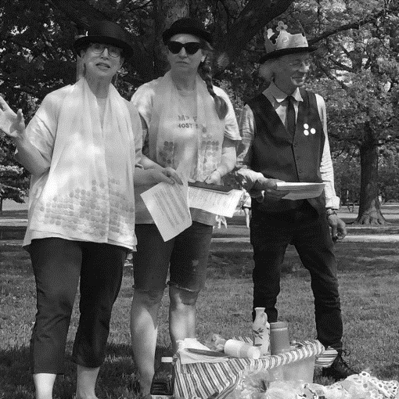
Flux mass scores were written/performed by two priestesses (Diane Keys & C. Mehrl Bennett), with assistance from deacon (Jonathan Stangroom), and congregation; Performed May 27, 2018, at Portage Park during Chicago Flux Fest, an annual event organized by Keith Buchholz. Buchholz is the baby being “born again” in the photo below by Andrew Oleksiuk.
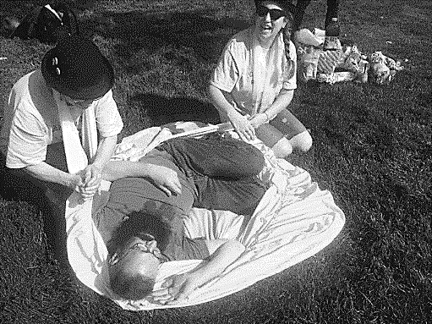
Above photo by Adamandia Kapsilis
Priestesses each wore a penny stole: first one was originally designed/sewn by Mary Campbell and C. Mehrl Bennett made a second stole fashioned after the first.

Objects on table: Red wine / dixie cups / candy body parts / peanut butter jar labeled “Wyrd of Glob” / glob spreader / “Wonder” bread – (slices for Glob & loaves for ”AfterGLOB event) / “Holy Bible” / pink materials to swaddle initiates / hand sanitizer labeled “Anti-Fluxus Gel” / “Flying Cow” suspended from a string/ hand bell

Deacon Duties:
Collection of Common Cents:
Bowler hat is used for collection plate - Deacon passes it around asking for "common cents" (a few pennies already in hat)
Liturgical Flux Packet of Prayer:
Deacon gives each member of the congregation a Liturgical Flux Packet of Prayer on which is printed prayer responses “Praise Cheezus Crust” and “Eminem”. M&Ms in packet are referred to as “Fluxpills”. Each pill is to be taken when giving the “Eminem” response [an alternative response to “Amen”]. - When priestesses say the following phrases: “Holy Bible” - “In God we Flux” - “Praise be to Glob” or other ritualistic phrases, the Deacon rings hand bell to signal for prayer responses. If congregation does not respond, the deacon must ask “Can I get an Eminem?”

Three Part Communion Ritual:
1) Open Bible revealing holes drilled inside and say, “Holy Bible”. Put straw thru biggest hole. Communion begins. Say “The Blood of Crust” as ‘wine’ or other purple liquid is poured through the big hole inside Holy Bible, and caught by communicant holding a cup underneath.
2) Communicant is given a candy body part using phrase, “The Body of Crust”. 3) Communicant is offered white bread and a knife for peanut butter, as priestesses ask each to “Spread the Wyrd of GLOB.”

After GLOB Event: BREAD FIGHT with loaves of Wonder Bread – (Feed leftover bread to chickens/birds/fish.) NOTE: BREAD FIGHT event is by Keith Buchholz, published under the title "Communion" in his book SCORES FOR A CHURCH, and was originally performed as part of FluxmaZZ at a church in Roanoke VA on 3/5/2011.

“Be Born Again” Ritual:
Priestesses swaddle each initiate in a pink cloth for the rebirthing ritual, rocking “the newborn” either on the ground or standing up, whichever they prefer. When initiate comes out of pink cocoon, they are told what a beautiful baby they are and anointed with “Anti-Fluxus Gel” (hand sanitizer) via an “X” on the forehead. Each born again baby is encouraged to praise each subsequent “born again” baby.

Eternal Circle Ritual:
The two priestesses wearing penny shawls perform this ritual, which is based on an old saying about an action for good luck, "See a penny, Pick it up." Priestesses each take pennies from the donation bowler hat and follow each other in a circle, alternately dropping and picking up pennies. Event ends when both stop dropping pennies or no more pennies can be found (which happened quickly because we performed on grass!).

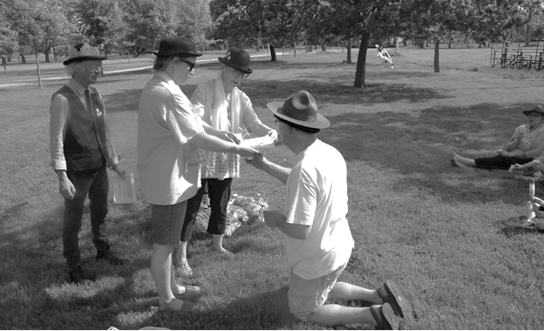
Photo by Allen Bukoff: From left is Jonathan Stangroom, Diane Keys, C. Mehrl Bennett,
Andrew Oleksiuk perform a “Blood of Crust” ritual.

